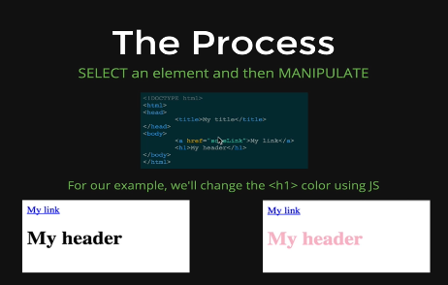

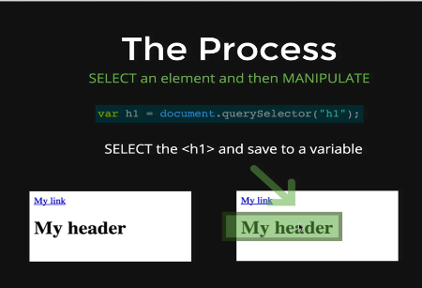

This is selecting the h1 element

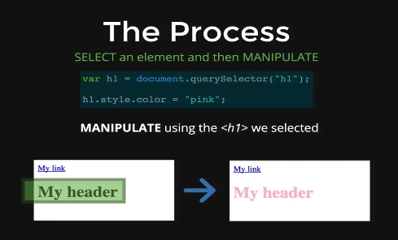

Here we are manipulating the element

Example:

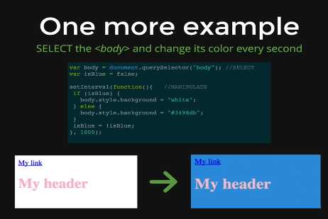

In this unit, the main thing we will discuss is the

Different way of selecting

Different way of manipulating